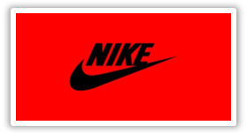
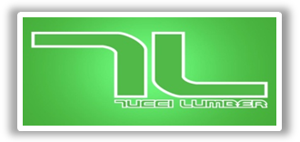
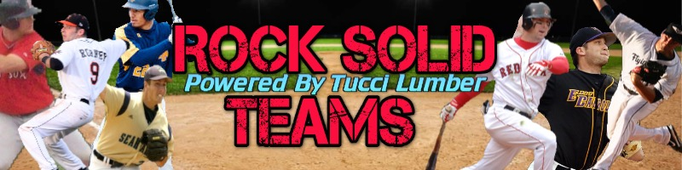

Rock Solid powered by Tucci Lumber is a baseball team bringing the best of the best together from up and down the East Coast, to compete in National Events. Playing with this team means you will be playing along side some of the top baseball talent. You will be coached by individuals who have had success at both the collegiate and professional levels. The coaches, evaluators and support team include but are not limited to 2004 World Series Champion Trot Nixon, former pro players Fletcher Bates (NY Mets), Pete Gilardo (Boston RedSox), Michael Rooney (Orioles), Brad Mincey (Marlins), Kenny Flythe (Collegiate), Jason Roach (Inside Recruit), Willie James (Atlanta Braves), Vic Picone (LI Ducks), Chris Frey (Go Wags), Pete Tucci (Tucci Lumber).
This team is not designed to pull players from their current teams. We believe in practicing and playing with your local teams. Practice is how you improve as a player! This team is to bring together players who are exceling and give them an opportunity to play better competition.
Players who make a team will receive:
What you will receive:
* top coaching staff
* outstanding players
* ultimate competition
* top ranked event
* rosters are not overcrowded
* competitive price
* future support from Rock Solid Coaches
* NO long term commitment
* COMMIT to practice event and ONE PERFECT GAME EVENT
* discounts on recruiting videos, SAT prep, Inside Recruiting Services

13U
Event Schedule/Cost:
- Evo- Classic @ Lake Point GA- June 12-16 ($265 player)

Our Uniforms will be Nike head to toe!
Uniform Package: $105.00- includes Hat and 3 jerseys. We will wear white pants and navy belt.

